ucp

Captsssure

|  |  |
| --- | --- |
| **Web Engineering**  **Assignment 03** | |
| **Course Code: SESD3233** | **Instructor: Muhammad Zahid Hussain** |
| **Marks: 20** | **Semester: Spring 2025** |
| **Due Date: 10th June 2025,11pm on portal only soft copy with screenshots**  **Instructions:**   * **Submission:**   + **All submissions will be on UCP Portal only. Upload zip files of code + screenshots.**   + **Ensure the code is functional and well-documented with comments**   + **You have to submit soft copy.**      - **For soft copy submission, upload a zip file containing all the required code files and screen shot of the output, name and roll number to the UCP Portal before 17th June 2025, 11:59pm.** * **Plagiarism Policy:** * **Strictly no plagiarism; ensure all work is original. In case of plagiarism, zero marks will be awarded.** | |
| |  |  | | --- | --- | | **Name** | **Roll Number** | | **Abdullah Maqbool** | **L1F23BSSE0391** | | |
| **Section: __M9____** | |

|  |  |  |
| --- | --- | --- |
| CLO 3 | Cognitive Level | Keywords |
| Students will be able to demonstrate frontend development proficiency by implementing best coding practices, utilizing modular JavaScript, functional programming, and showcasing technical knowledge and communication skills through project development, presentations, and viva assessment | C6 | Write, Create |

**Question 01 (CLO-03) 05 Marks**

**Task 01: Accessing HTML Elements and Changing Attribute Values with Events**

**Before toggle:**

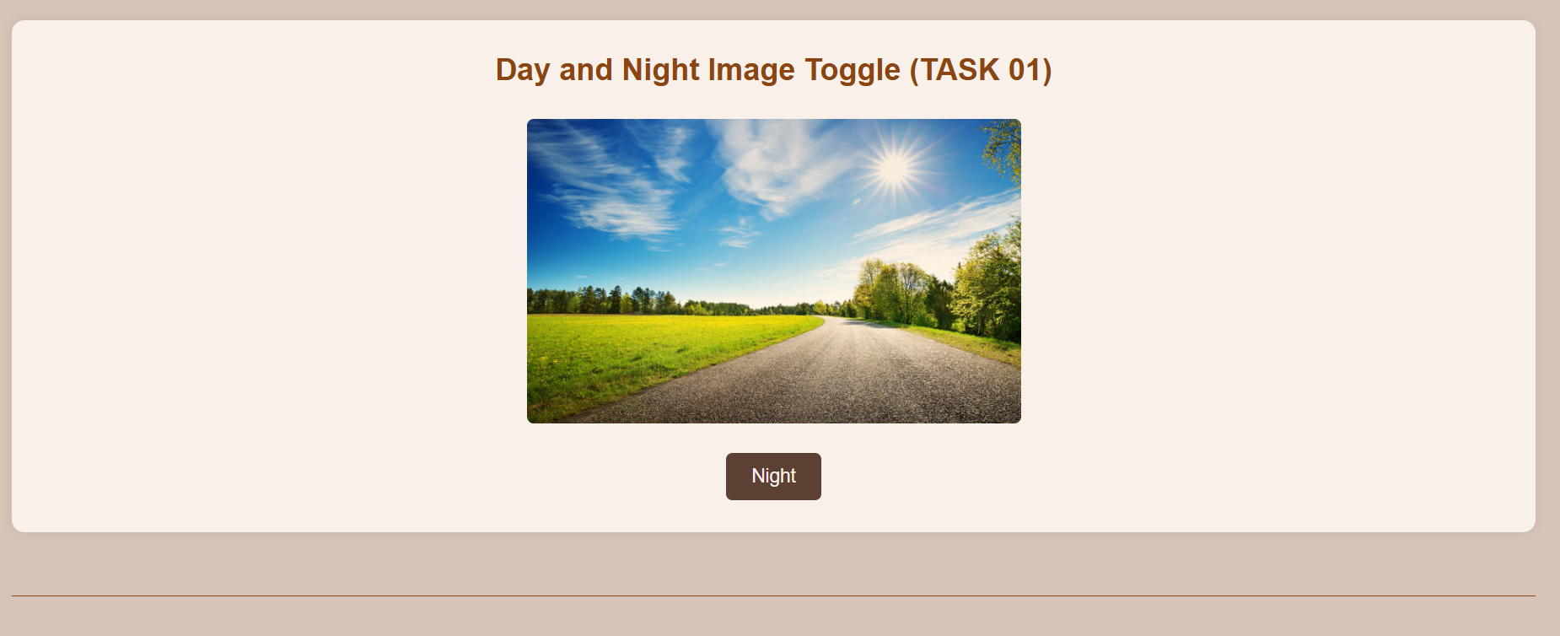

**After toggle:**

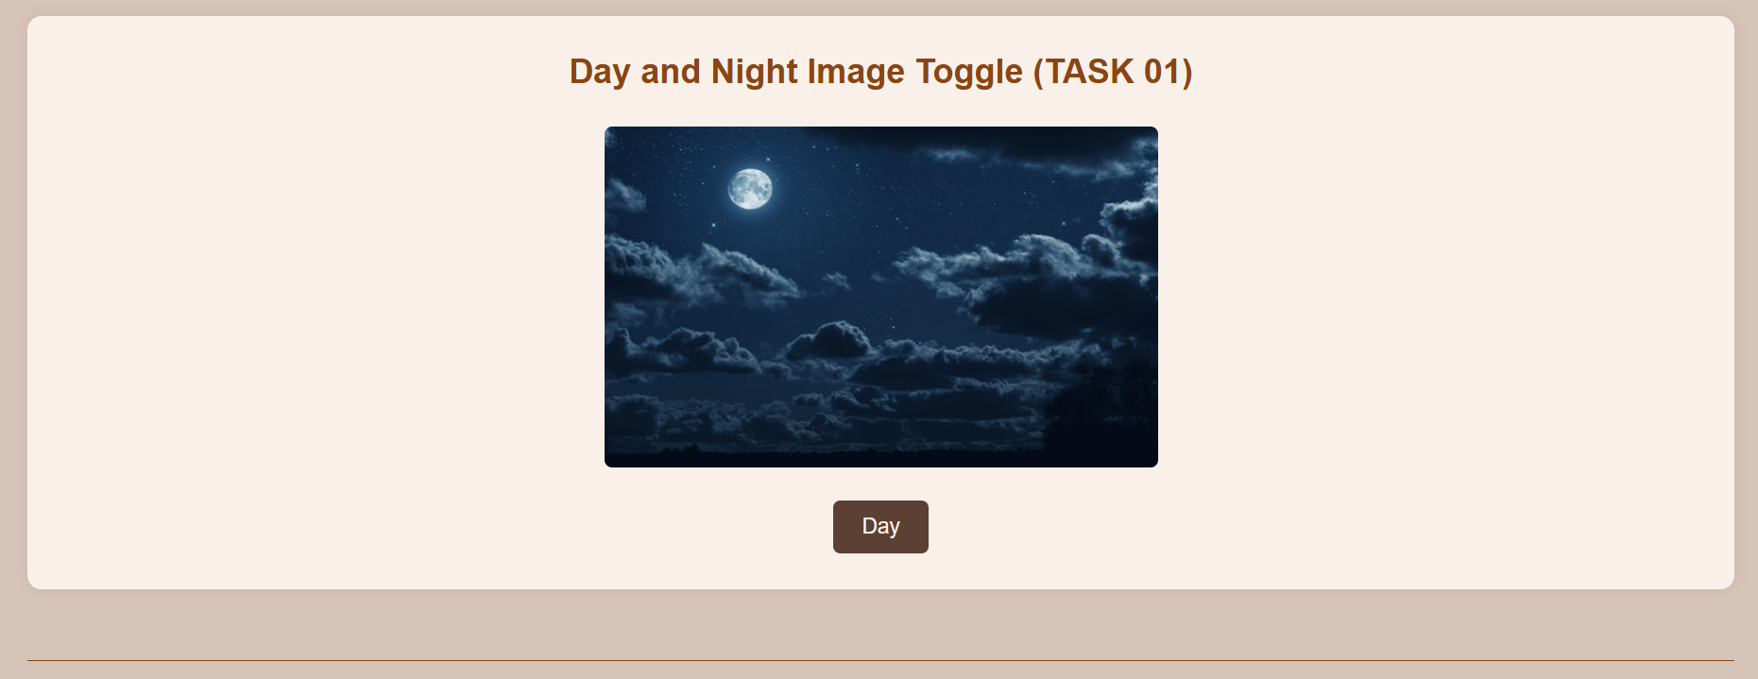

**Question 02 (CLO-03) 05 Marks**

**Task 02: Dynamic Content Replacement with Events**

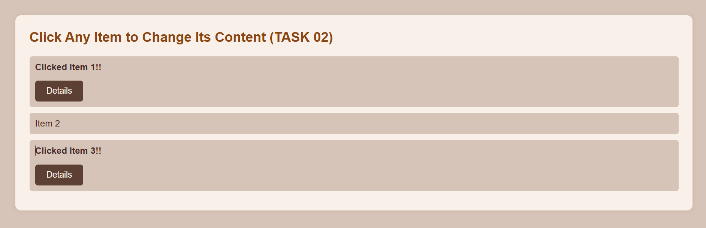

**Question 03 (CLO-03) 05 Marks**

**Task 03: Adding New HTML Elements Dynamically with Events**

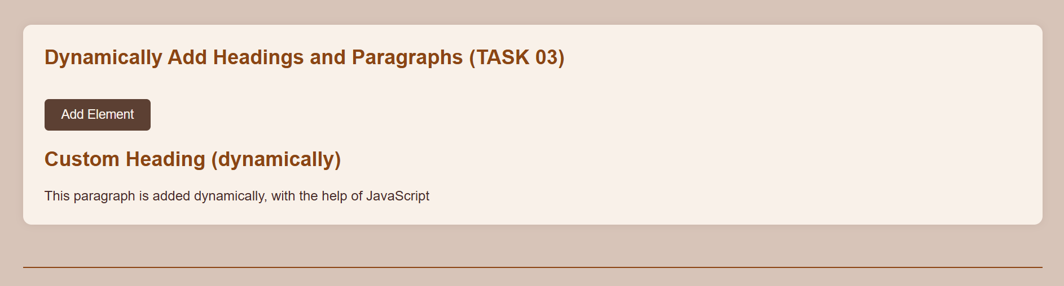

**Question 04 (CLO-03) 05 Marks**

